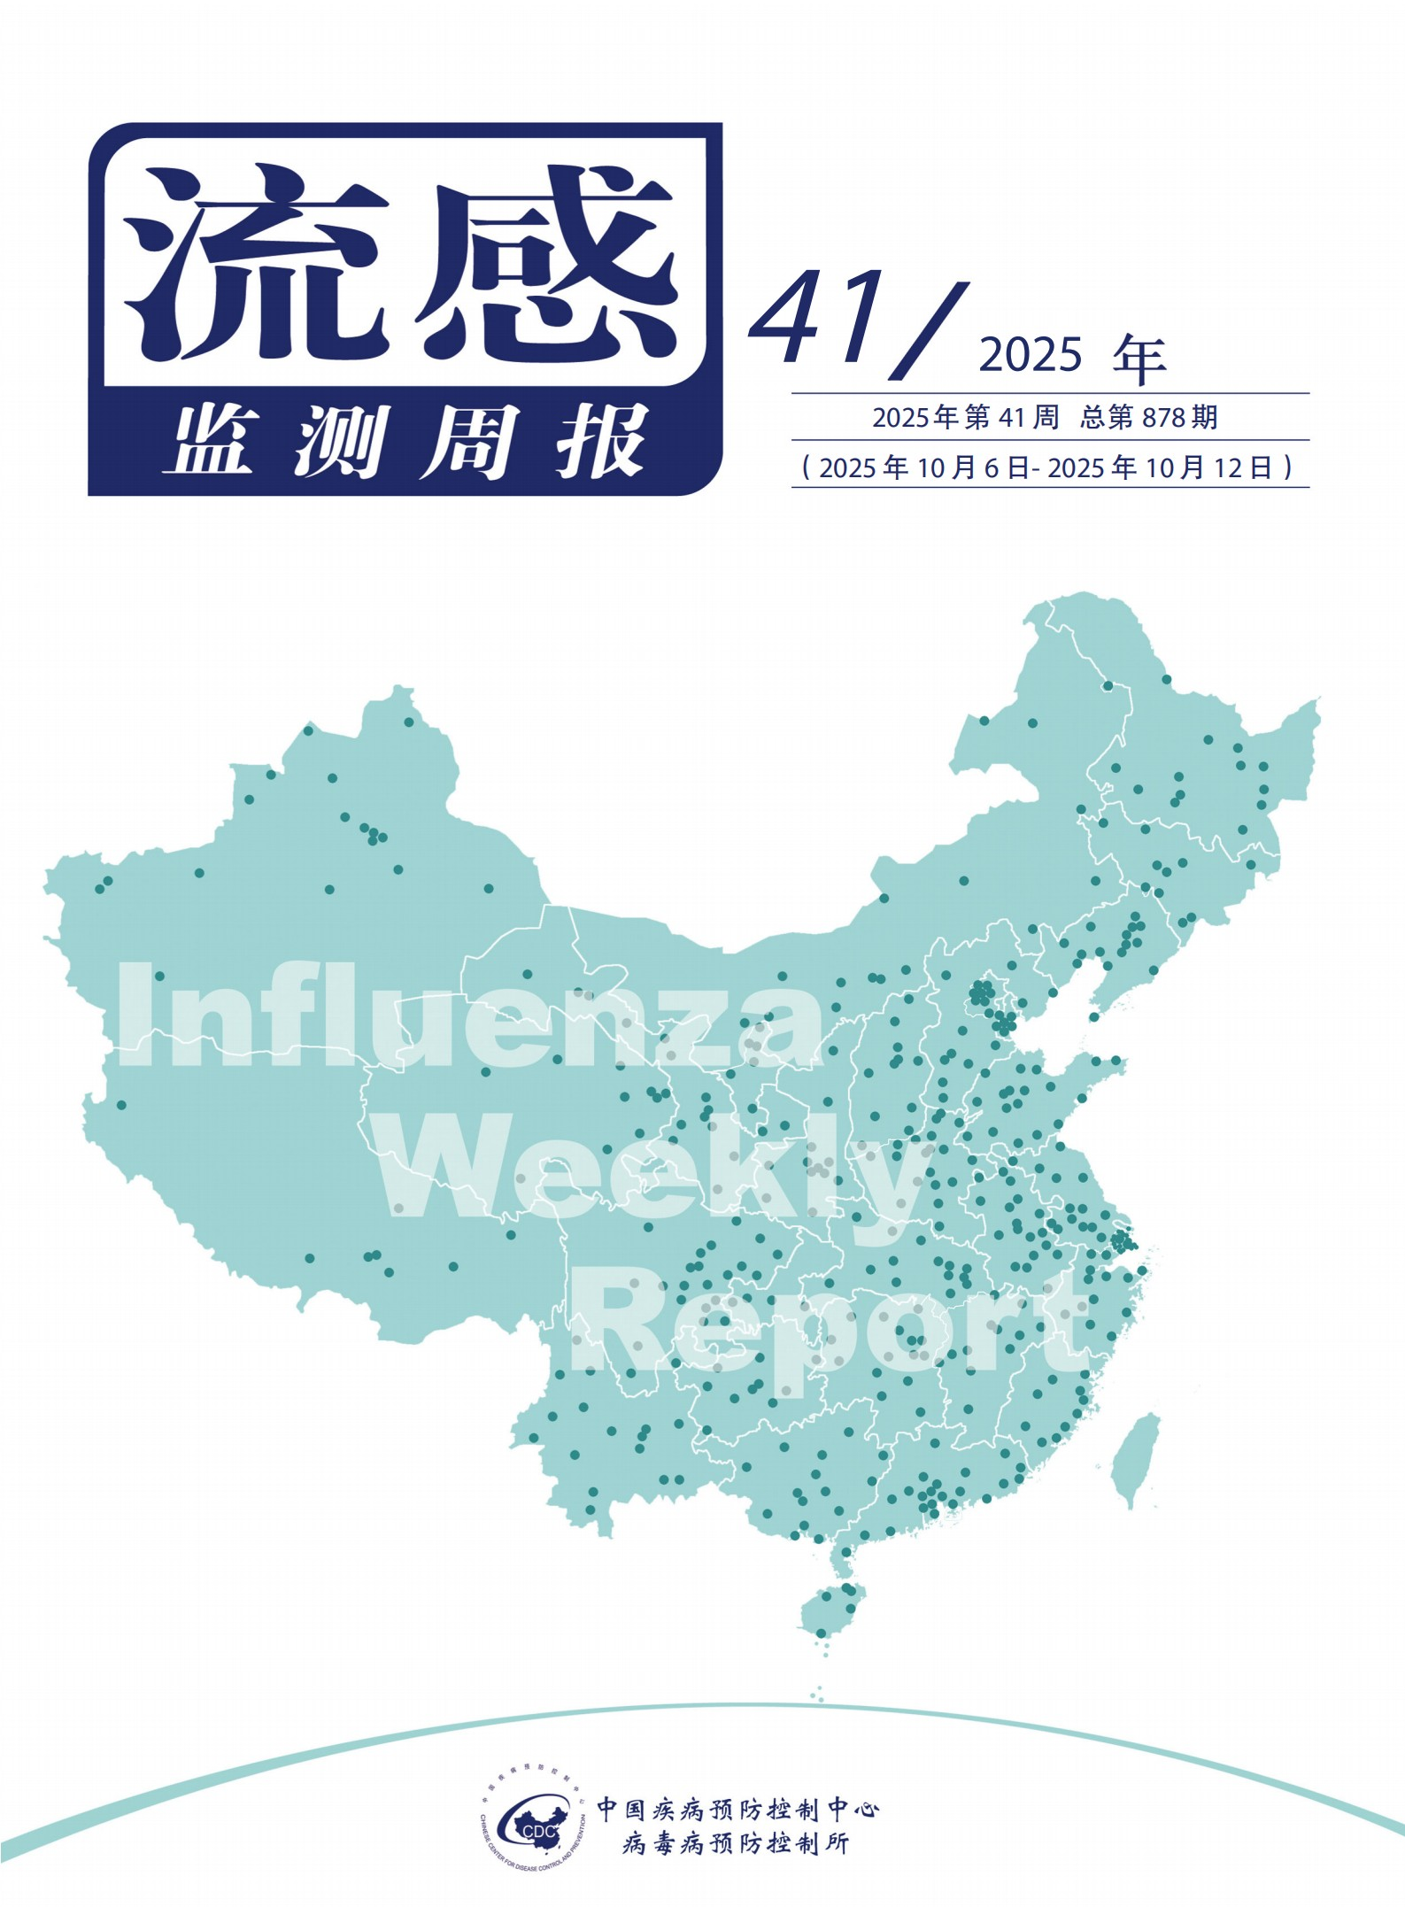

Table of Contents

CONTENTS

01 summary

 03 1. Influenza-like case reports



Influenza Surveillance Weekly Report

05 2. Etiological monitoring

08 3. Outbreak of the epidemic

1. 4. Human infection with animal-derived influenza virus epidemics
2. 5. Animal avian influenza epidemic
3. 6. Influenza surveillance in other countries/regions

In the 41st week of 2025 (October 6, 2025 - October 12, 2025), sentinel hospitals in the southern provinces reported an ILI% of 4.1%, lower than the previous week level (4.2%), higher than the same period in 2022 and 2024 (3.0% and 3.3%), and lower than the same period in 2023

（4.8%）。

In week 41 of 2025, sentinel hospitals in the northern provinces reported an ILI% of 2.8%, lower than the previous week (3.2%), higher than the same period in 2022 (2.6%), and lower than the same period in 2023 and 2024 (3.0% and 3.2%).

# 2. Etiological monitoring



1. Influenza-like case reports

pick

want

Summary of influenza epidemic in China

(As of.)

202

5

year

10

month

12

day)

·

Monitoring data show that

Week

Influenza activity is low in the northern provinces

, influenza activity in southern provinces increased

。

nationwide

common

report

tell

4

rise

influenza

The outbreak of the epidemic in the sample case.

·

The National Influenza Center responded

202

5

year

3

month

31

Day-

2025

year

10

month

12

Some streams received during the day (counted by experimental date).

Antigenicity analysis was carried out for susceptible virus strains

，

The results show

：

at

A(H1N1)pdm09

There are subtype influenza virus strains

98.

4

%

（

1026

/

1043

）

for

A/Victoria/4897/2022

similar strains; at

A(H3N2)

There are subtype influenza virus strains

56.7

%

（

1

90

/

335

）

for

A/Croatia/10136RV/2023

（

Chicken embryo strain

）

similar strains

，

91.6

%

（

307

/

335

）

for

A/District

of

Columbia/27/2023

(Cell line.)

）

similar strains

；

at

B(Victoria)

It is found in the flu virus

98.2

%

（

215

/

219

）

for

B/Austria/1359417/202

1

similar strains.

·

The National Influenza Center responded

202

5

year

3

month

31

Some influenza virus strains collected for testing in the past day were analyzed for drug resistance, and the results showed that:

at

A(H1N1)pdm09

There are subtype influenza virus strains

4.2

%

（

30

/

716

Reduced or highly reduced sensitivity to neuraminidase inhibitors,

rest

A(H1N1)pdm09

The subtype influenza virus strains were all sensitive to neuraminidase inhibitors. all

A(H3N2)

subtypes and

B

Influenza disease

All virulent strains are sensitive to neuraminidase inhibitors

；

all

A(H1N1)pdm09

、

A(H3N2)

subtypes and

B

Influenza virus strains are all polymerized

Enzyme inhibitor sensitivity.

In the 41st week of 2025, influenza-like case surveillance specimens were detected in influenza-like case surveillance laboratories across the country (excluding Hong Kong, Macao and Taiwan).

18714 copies. 539 positive specimens for the influenza virus were detected in the southern provinces, of which 26 were A(H1N1)pdm09 and 472 were A(H3N2),

41 copies are B (Victoria). 74 positive specimens for influenza virus were detected in the northern provinces, of which 2 were A(H1N1)pdm09 and 67 were detected

A (H3N2), 5 copies are B (Victoria). The number and proportion of influenza types and subtypes detected in southern and northern provinces are shown in Table 1.

## 01

Table 1 Laboratory test results for monitoring influenza-like cases

|  |  |  |  |
| --- | --- | --- | --- |
|  | Week 41 | |  |
| Southern provinces | Northern provinces | total |
| Number of Detections | **10033** | **8681** | **18714** |
| Number of positives **(%)** | **539(5.4%)** | **74(0.9%)** | **613(3.3%)** |
| **Type A** | **498(92.4%)** | **69(93.2%)** | **567(92.5%)** |
| A(H1N1)pdm09 | 26(5.2%) | **2(2.9%)** | **28(4.9%)** |
| A(H3N2) | 472(94.8%) | 67(97.1%) | 539(95.1%) |
| A(unsubtyped) | 0 | 0 | 0 |
| **Type B** | **41(7.6%)** | **5(6.8%)** | **46(7.5%)** |
| B is not classified | 0 | 0 | 0 |
| Victoria | 41(100.0%) | 5(100.0%) | 46(100.0%) |
| Yamagata | 0 | 0 | 0 |

In the 41st week of 2025, the National Influenza Center analyzed 26 strains of A(H1N1)pdm09, 96 strains of A(H3N2) subtypes, and 37 B (Victoria) influenza strains for resistance to neuraminidase inhibitors, all of which were sensitive to neuraminidase inhibitors.

# 3. Outbreak of the epidemic

In the 41st week of 2025, a total of 4 outbreaks of influenza-like cases were reported nationwide. After testing, 2 cases were A(H3N2), 1 case was negative for influenza, and 1 case had no pathogen test results.

## 02

1. Percentage of influenza-like cases in the total number of outpatient and emergency cases in southern provinces.
   1. In the 41st week of the year (October 6, 2025 - October 12, 2025), sentinel hospitals in the southern provinces reported an ILI% of 4.1%, lower than the previous week level (4.2%), higher than the same period in 2022 and 2024 (3.0% and 3.3%), and lower than the same period in 2023



（

4.8

%

）。

（

fig

1

）

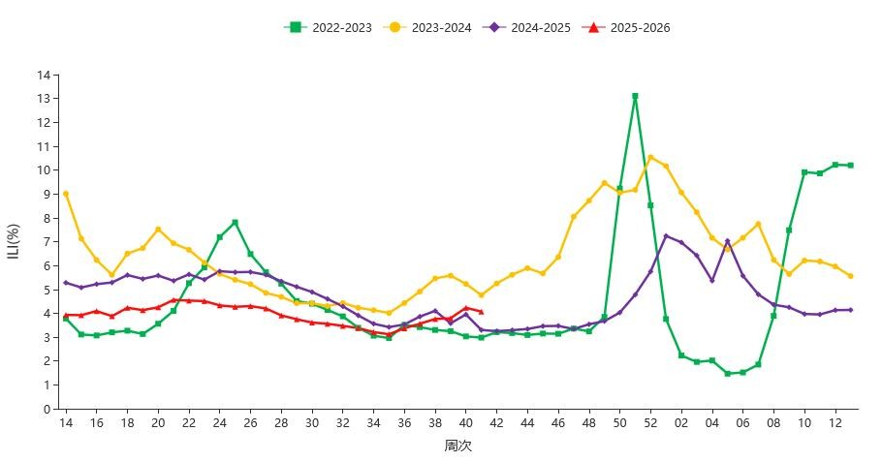

fig

1

2022

－

2026

Influenza-like cases reported annually at sentinel hospitals in southern provinces

%

Note: The data comes from the national sentinel hospital.

Influenza-like case reports

1. Percentage of influenza-like cases in the total number of outpatient and emergency cases in the northern provinces.
   1. In week 41 of the year, Sentinel Hospitals in the Northern Provinces reported an ILI% of 2.8%, lower than the previous week (3.2%), higher than the same period in 2022 (2.6%), and lower than the same period in 2023 and 2024 (3.0% and 3.2%). (Figure 2)

03

04

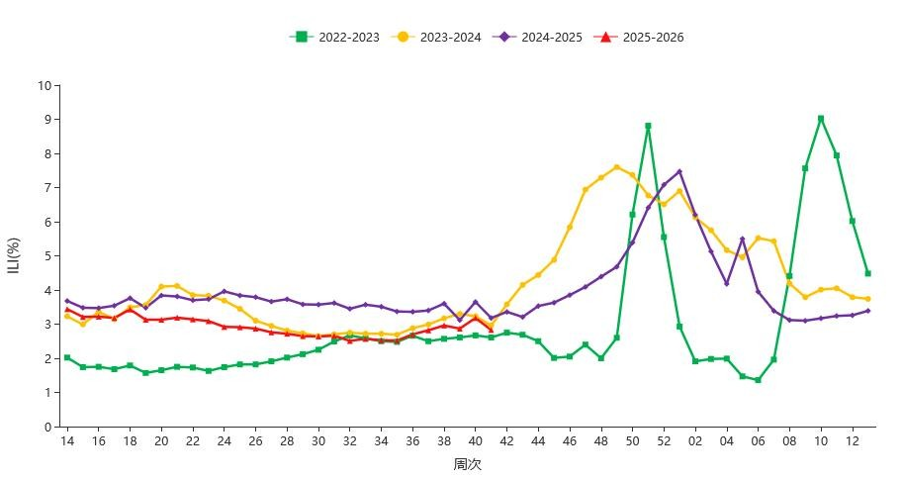

fig

2

20

2

2

－

2026

Influenza-like cases reported annually at sentinel hospitals in northern provinces

%

Note: The data comes from the national sentinel hospital.

# (1) Surveillance of influenza-like cases

1. Southern provinces.

|  |
| --- |
| Etiological monitoring |

In the 41st week of 2025, 539 positive specimens of the influenza virus were detected in the southern provinces, of which 26 were A(H1N1)pdm09, 472 were A(H3N2) and 41 were B (Victoria). Specific data for each type are shown in Table 1 and Figure 3.

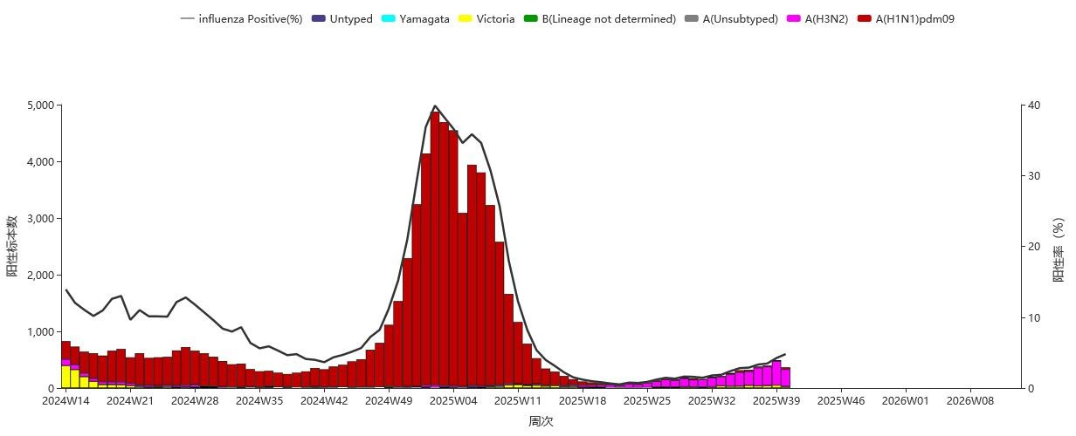

fig

3

Southern provinces

PROVINCE

Specimen test results

Note: The data comes from the test results of the network laboratory, the results of the network laboratory and

CNIC

The results are inconsistent

CNIC

The results of the review shall prevail.

2

Northern provinces.

In week 41 of 2025, 74 positive specimens of influenza virus were detected in the northern provinces, of which 2 were A(H1N1)pdm09, 67 were A(H3N2) and 5 were B (Victoria). Specific data for each type are shown in Table 1 and Figure 4.

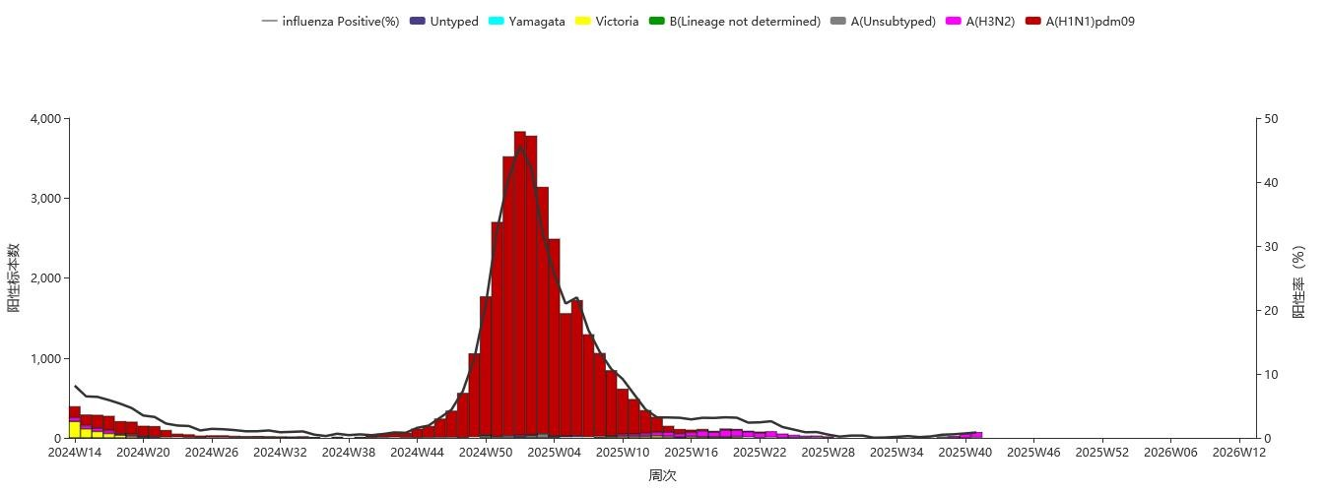

Figure 4 ILI specimen test results in the northern provinces

Note: The data comes from the test results of the network laboratory, and if the network laboratory results are inconsistent with the CNIC results, the results of the CNIC review shall prevail.

05

# (2) ILI outbreak laboratory test results

1. Southern provinces.

In the 41st week of 2025, the network laboratory in the southern province did not receive an outbreak specimen of influenza-like cases. (Figure 5)

(Figure 6)

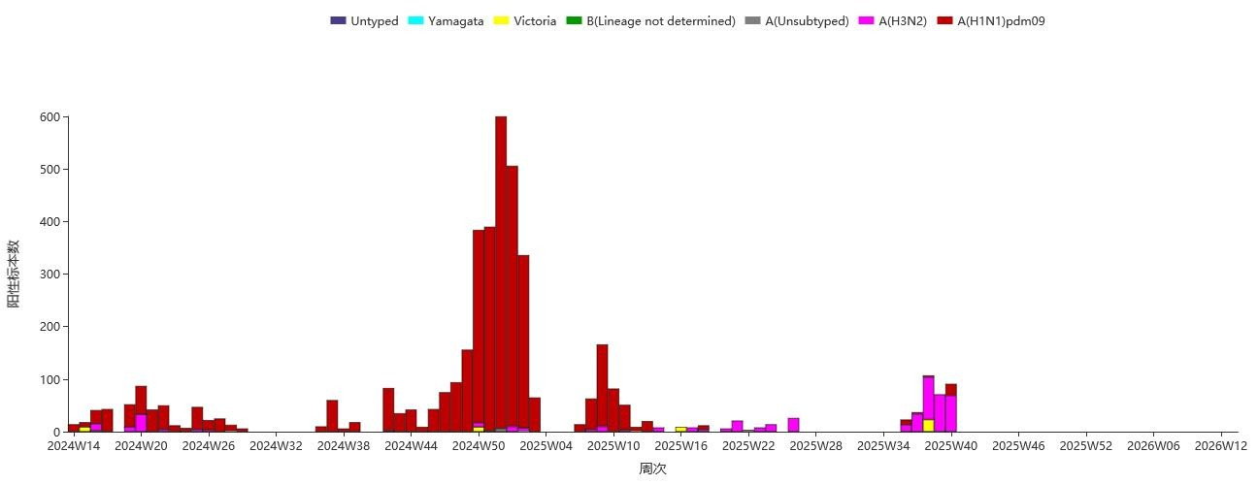

fig

5

Southern provinces

PROVINCE

Test results of outbreak specimens

Note: The data comes from the test results of the network laboratory, the results of the network laboratory and

CNIC

The results are inconsistent

CNIC

The results of the review shall prevail.

2.

Northern provinces.

202

5

year

clause

4

1

week

，

north

Fang Province Network Laboratory

common

Inspection

arrive

3

portion

Outbreak specimens of influenza-like cases

，

equal

for

A(H1N1)pdm09

。

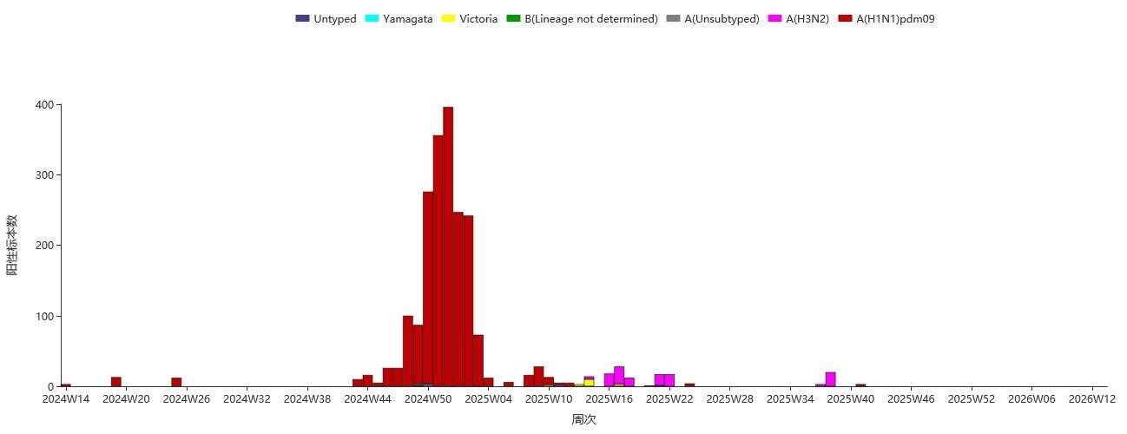

Figure 6 Specimen test results of ILI outbreaks in northern provinces Note: The data comes from the test results of the network laboratory, and the results of the CNIC review shall prevail if the results of the network laboratory and the CNIC results are inconsistent.

# (3) Antigenicity analysis

From March 31, 2025 to October 12, 2025 (by experimental date), CNIC conducted antigenicity analysis on 1043 A(H1N1)pdm09 subtype influenza strains, of which 1026 (98.4%) were similar to A/Victoria/4897/2022 and 17 (1.6%) were low-response strains of A/Victoria/4897/2022. Antigenicity analysis was performed on 335 A(H3N2) subtype influenza strains, of which 190 were performed

(56.7%) were similar to A/Croatia/10136RV/2023 (chicken embryo strain), and 145 (43.3%) were A/Croatia/10136RV/2023

(chicken embryo strain); Among them, 307 strains (91.6%) were similar strains of A/District of Columbia/27/2023 (cell line),

## 06

Twenty-eight (8.4%) were low-response strains from A/District of Columbia/27/2023 (cell line). Antigenicity analysis was performed on 219 B (Victoria) influenza strains, of which 215 (98.2%) were similar to B/Austria/1359417/2021 and 4 (1.8%) were strains

B/Austria/1359417/2021 low-response strain.

# (4) Drug resistance analysis

In the 41st week of 2025, the National Influenza Center analyzed the resistance of 26 strains of A(H1N1)pdm09, 96 strains of A(H3N2) and 37 strains of B (Victoria) influenza strains, all of which were sensitive to neuraminidase inhibitors.

From March 31, 2025 to October 12, 2025, CNIC resistance surveillance data showed that except for 30 A(H1N1)pdm09 influenza strains with reduced or highly reduced sensitivity to neuraminidase inhibitors, the remaining A(H1N1)pdm09 influenza strains were sensitive to neuroaminase inhibitors. All A(H3N2) and B fluid-sensing strains were sensitive to Shen Jing aminase inhibitors. Yes

Influenza A(H1N1)pdm09, A(H3N2) subtypes and B influenza strains are all sensitive to polymerase inhibitors.

## 07

Definition of influenza-like case outbreaks: Within a week, 10 or more influenza-like cases occur in the same region or unit, verified and confirmed by county (district) level disease prevention and control agencies, and reported through the "China Influenza Surveillance Information System" is defined as one influenza-like case outbreak.

1. Overview of the outbreak reported this week.
   1. In the 41st week of the year, a total of 4 flu-like outbreaks were reported nationwide. After testing, 2 cases were A(H3N2), 1 case was negative for influenza, and 1 case had no pathogen test results.
2. Overview of the outbreak.
   1. From March 31, 2025 to October 12, 2025, 92 outbreaks of influenza-like cases (10 cases and above) were reported nationwide from the 14th to 41st week of the year (March 31, 2025-October 12, 2025), 58 were A(H3N2), 5 were A(H1N1)pdm09, 3 were A(H1N1)pdm09, 3 were type A (subtype not shown), 4 were B (Victoria), 6 were mixed, 8 were influenza-negative, and 8 were not yet available for pathogen detection.

1. Time distribution.

In weeks 14-41 of 2025, a total of 62 ILI outbreaks were reported in the Southern Provinces, down from the number of reported outbreaks in the same period in 2024 (100).

(Figure 7)

In weeks 14-41 of 2025, a total of 30 ILI outbreaks were reported in the northern provinces, up from the same period in 2024 (23).

Outbreak of the epidemic

(Figure 8)

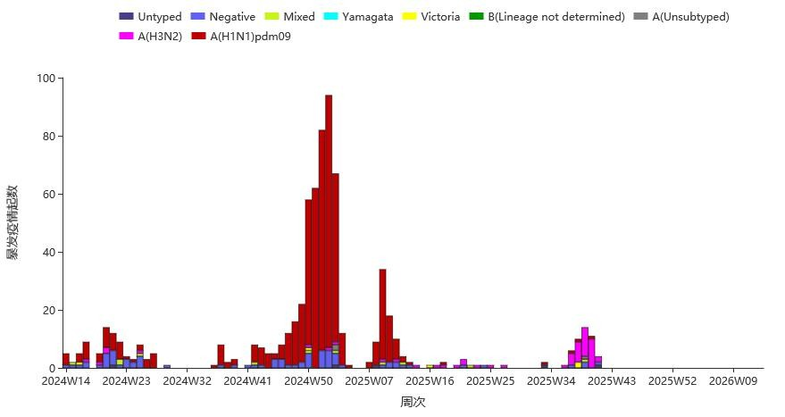

Figure 7 Southern provinces report weekly distribution of ILI outbreaks

(According to the time of epidemic report)

## 08

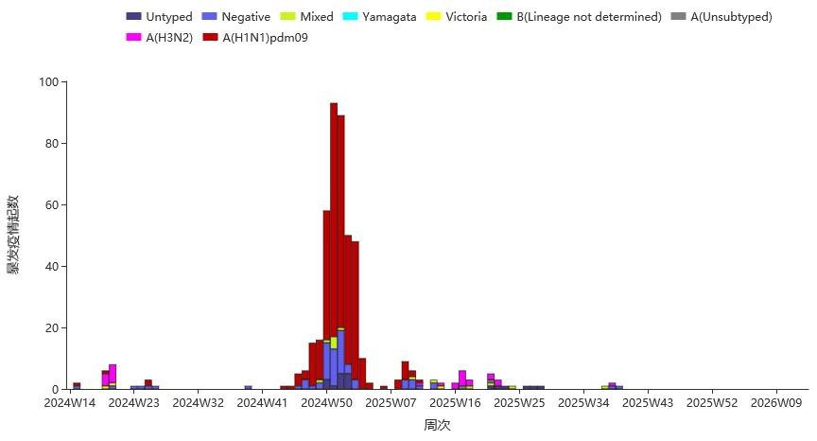

Figure 8 The northern provinces report weekly distribution of ILI outbreaks

(According to the time of epidemic report)

In weeks 14-41 of 2025, a total of 92 ILI outbreaks were reported nationwide across 6 regions (Table 2).

Table 2 Outbreaks reported by region during weeks 14-41 of 2025

|  |  |  |  |
| --- | --- | --- | --- |
| region | Number of outbreaks (start) | region | Number of outbreaks (start) |
| southwest | 31 | East | 16 |
| South | 24 | Central | 3 |
| Northwest Territories | 17 | North China | 1 |

Note: The outbreak report is affected by factors such as local monitoring capacity and monitoring sensitivity. The provinces and cities in each region are as follows: Northeast China: Heilongjiang, Jilin, Liaoning; North China: Beijing, Hebei, Inner Mongolia, Shanxi, Tianjin; East China: Anhui, Fujian, Jiangsu, Jiangxi, Shandong, Shanghai, Zhejiang; South China: Guangdong, Guangxi, Hainan; Central China: Henan, Hubei, Hunan; Northwest region: Gansu, Construction Corps, Ningxia, Qinghai, Shaanxi, Xinjiang; Southwest region: Guizhou, Sichuan, Tibet, Yunnan, Chongqing.



2

Regional distribution.

## 09

WHO has not reported human infection with animal-derived influenza viruses.

person

feel

dye

move

thing

source

sex

flow

feel

sickness

poison

pestilence

feeling

（译自：[https://www.who.int/teams/global-influenza-programme/avian-influenza/monthl](https://www.who.int/teams/global-influenza-programme/avian-influenza/monthly-risk-assessment-summary) y[risk-assessment-summary](https://www.who.int/teams/global-influenza-programme/avian-influenza/monthly-risk-assessment-summary) [）](https://www.who.int/teams/global-influenza-programme/avian-influenza/monthly-risk-assessment-summary)

From October 5 to 11, 2025, the World Organisation for Animal Health reported a total of 31 animal outbreaks of highly pathogenic avian influenza.

move

thing

fowl

flow

feel

pestilence

feeling

Table 3 Global outbreaks of highly pathogenic avian influenza in animals

|  |  |  |  |  |  |
| --- | --- | --- | --- | --- | --- |
| Country | Avian influenza subtypes | | | | |
| H5N1 | H5N5 | H5 (N TBD) | To be reported | total |
| Argentina |  |  |  | 1 | 1 |
| Bulgaria | 1 |  |  |  | 1 |
| Denmark | 2 |  |  |  | 2 |
| France | 1 |  |  |  | 1 |
| Germany | 4 |  |  |  | 4 |
| India | 2 |  |  |  | 2 |
| Iran | 1 |  |  |  | 1 |
| Ireland | 1 |  |  |  | 1 |
| Italy | 1 |  |  |  | 1 |
| Latvia | 1 |  |  |  | 1 |
| Netherlands | 1 |  |  |  | 1 |
| Poland | 2 |  |  |  | 2 |
| Portugal | 1 |  |  |  | 1 |
| Slovakia | 1 |  |  |  | 1 |
| Spain | 1 |  |  |  | 1 |
| Sweden | 1 |  |  |  | 1 |
| United Kingdom | 5 | 1 |  |  | 6 |
| United States | 2 |  | 1 |  | 3 |
| total | 28 | 1 | 1 | 1 | 31 |

## Worldwide (Week 39, data as of September 28, 2025)

Influenza surveillance Globally, influenza activity remains low, and type A continues to dominate. The northern and southern hemispheres and the dissemination regions exhibit different patterns.

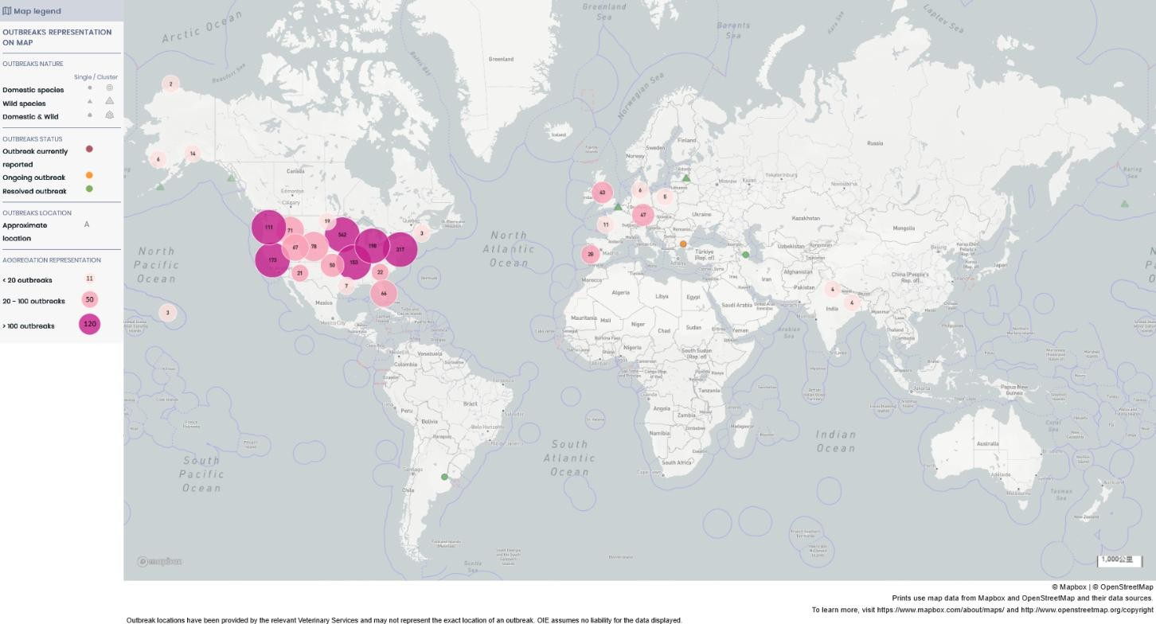

fig

9

whole

ball

report

tell

move

thing

feel

dye

high

send

sickness

sex

fowl

flow

feel

pestilence

feeling

empty

space

divide

cloth

（

translate

self

：

[h](https://wahis.woah.org/)

[t](https://wahis.woah.org/)

[t](https://wahis.woah.org/)

[p](https://wahis.woah.org/)

[s](https://wahis.woah.org/)

[:](https://wahis.woah.org/)

[/](https://wahis.woah.org/)

[/](https://wahis.woah.org/)

[in](https://wahis.woah.org/)

[a](https://wahis.woah.org/)

[h](https://wahis.woah.org/)

[i](https://wahis.woah.org/)

[s](https://wahis.woah.org/)

[.](https://wahis.woah.org/)

[in](https://wahis.woah.org/)

[or](https://wahis.woah.org/)

[a](https://wahis.woah.org/)

[h](https://wahis.woah.org/)

[.](https://wahis.woah.org/)

[or](https://wahis.woah.org/)

[r](https://wahis.woah.org/)

[g](https://wahis.woah.org/)

[/](https://wahis.woah.org/)

[#](https://wahis.woah.org/)

[/](https://wahis.woah.org/)

[h](https://wahis.woah.org/)

[or](https://wahis.woah.org/)

[m](https://wahis.woah.org/)

[and](https://wahis.woah.org/)

[）](https://wahis.woah.org/)

that

he

country

family

/

earth

district

flow

feel

supervise

measure

feeling

condition

In the southern hemisphere, most countries reported low and stable influenza activity, and some countries in East Africa and Southeast Asia reported an increase in influenza positivity (>10%). In the Northern Hemisphere, most countries or regions have had low and stable levels of influenza activity over the past few weeks. A few countries in Central and Caribbean, West and Central Africa, West and Central Africa, West Asia, South Asia, and Southeast Asia have influenza positivity rates of more than 30%. Central America and the Caribbean, West and Central Africa, South Asia, and Southeast Asia are on the rise.

In areas of transmission with high influenza positivity rates, A(H1N1)pdm09 is predominant in Central America and the Caribbean, East and Central Africa, A(H3N2) is dominant in Asia, and A(H1N1)pdm09 and A(H3N2) are reported in West Africa.

Coronavirus (SARS-CoV-2) surveillance

Globally, the new crown positivity rate is still low but slightly increasing, with a small number of countries in Central America and the Caribbean, tropical South America, Europe, West Asia and East Asia monitoring the new crown positivity rate of more than 30%. Two countries in southwestern Europe and one country in tropical South America grew.

Respiratory syncytial virus (RSV) surveillance

Respiratory syncytial virus (RSV) positivity rates remain high in some Central American and Caribbean countries and some countries in tropical and temperate South America, West Africa and East Asia, with two countries in Central America and the Caribbean reporting a slight increase.

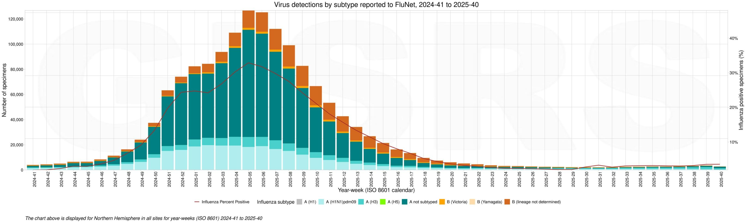

fig

1

0

north

half

ball

flow

feel

sickness

poison

flow

Yes

feeling

condition

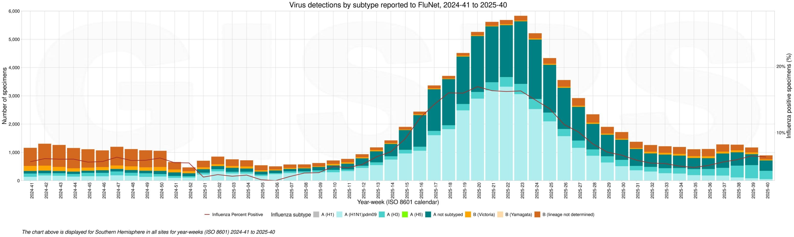

Figure 11 Influenza virus epidemic in the southern hemisphere

(Translated from:

[https://www.who.int/teams/global-influenza-programme/surveillance-and-monitoring/ inf luenza-updates/current-influenza-upda](https://www.who.int/teams/global-influenza-programme/surveillance-and-monitoring/influenza-updates/current-influenza-update)te）

## United States (Week 38, data as of September 20, 2025. Not updated yet. ）

At week 38, seasonal influenza activity levels were low across the United States.

1.7% of patients reported through ILINet this week were flu-like cases (i.e., due to respiratory illness, including fever with cough or sore throat, also known as ILI). Many respiratory viruses are prevalent, and the impact of influenza virus infection on ILI may vary by location.

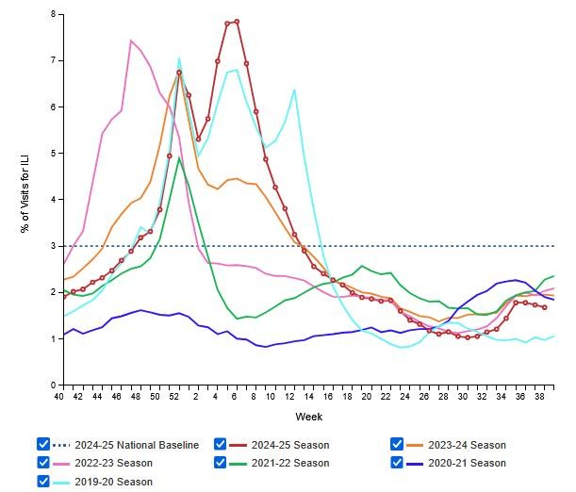

fig

1

2

beauty

country

I

L

I

supervise

measure

week

divide

cloth

root

week

Pro

bed

true

examine

room

common

examine

measure

shape

root

4

5

1

9

4

portion

，

examine

go out

1

6

0

portion

（

0

.

4

%

）

flow

feel

sickness

poison

yang

sex

：

that

middle

A

type

1

4

0

portion

（

8

7

.

5

%

）

，

B

type

2

0

portion

（

1

2

.

5

%

）

。

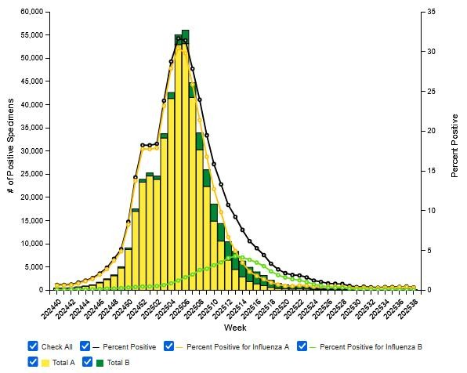

Figure 13 Weekly distribution of influenza pathogen surveillance in clinical laboratories in the United States

A total of 371 samples were tested by U.S. public health laboratories this week, and 27 positive influenza samples were detected, of which 25 (92.6%) were type A and 2 (7.4%) were type B. Of the 15 (60.0%) typed type A samples, 6 (40.0%) were A(H1N1)pdm09 subtypes, 9 (60.0%) were A(H3N2) subtypes, and 10 (40.0%) were A(not shown). 2 copies of type B unstrained.

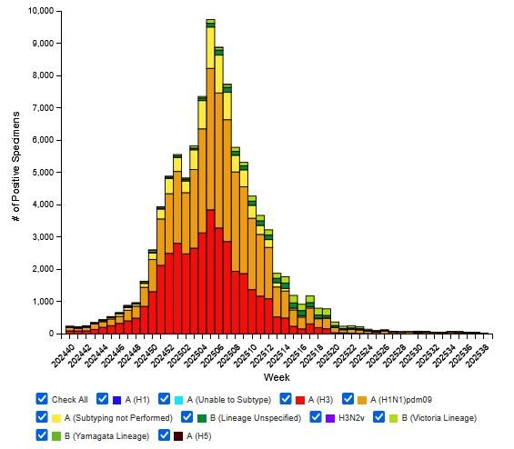

fig

1

4

beauty

country

public

common

protect

bear

true

examine

room

flow

feel

sickness

original

supervise

measure

week

divide

cloth

root

week

report

tell

die

in

flow

feel

target

die

lose

person

number

occupy

whole

division

die

lose

person

number

target

0

.

0

3

%

。

place

raise

supply

target

number

occupy

be

beginning

step

target

，

can

Yes

Yes

follow

make move

pick up

harvest

and

place

reason

more

many

number

occupy

whereas

hair

bear

change

change

。

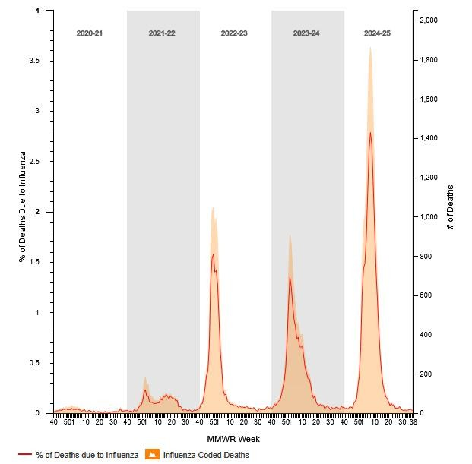

Figure 15 U.S. Influenza Death Surveillance

(Translated from: [https://www.cdc.gorv/fluview/index.html](https://www.cdc.gov/fluview/index.html) ）

## Hong Kong, China (Week 40, September 28 - October 8, 2025)

Hong Kong is in the summer flu season. The latest surveillance data show that the local influenza activity in Hong Kong remains at a high level.

The average proportion of ILI reported by designated general practice clinics in Hong Kong this week was 11.4‰, down from 11.7‰ last week.

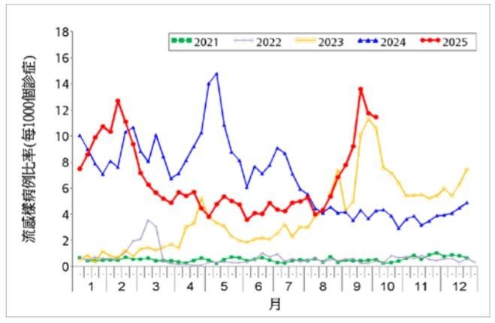

fig

1

6

fragrant

harbor

decide

dot

general

open

section

Diagnosis

place

I

L

I

supervise

measure

week

divide

cloth

root

week

fragrant

harbor

decide

dot

private

family

medical

bear

place

report

tell

target

I

L

I

flat

equal

compare

example

for

4

1

.

3

‰

，

low

in

above

week

target

4

3

.

4

%

。

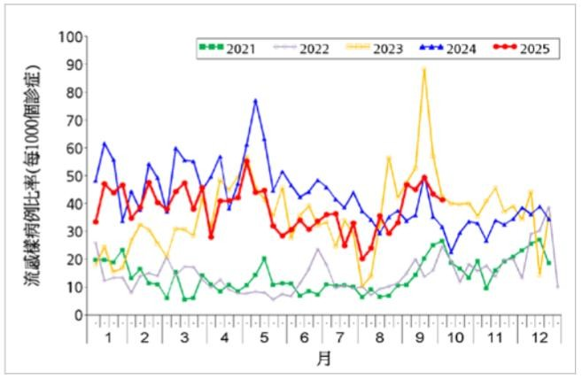

Figure 17 Weekly distribution of ILI surveillance among designated private doctors in Hong Kong

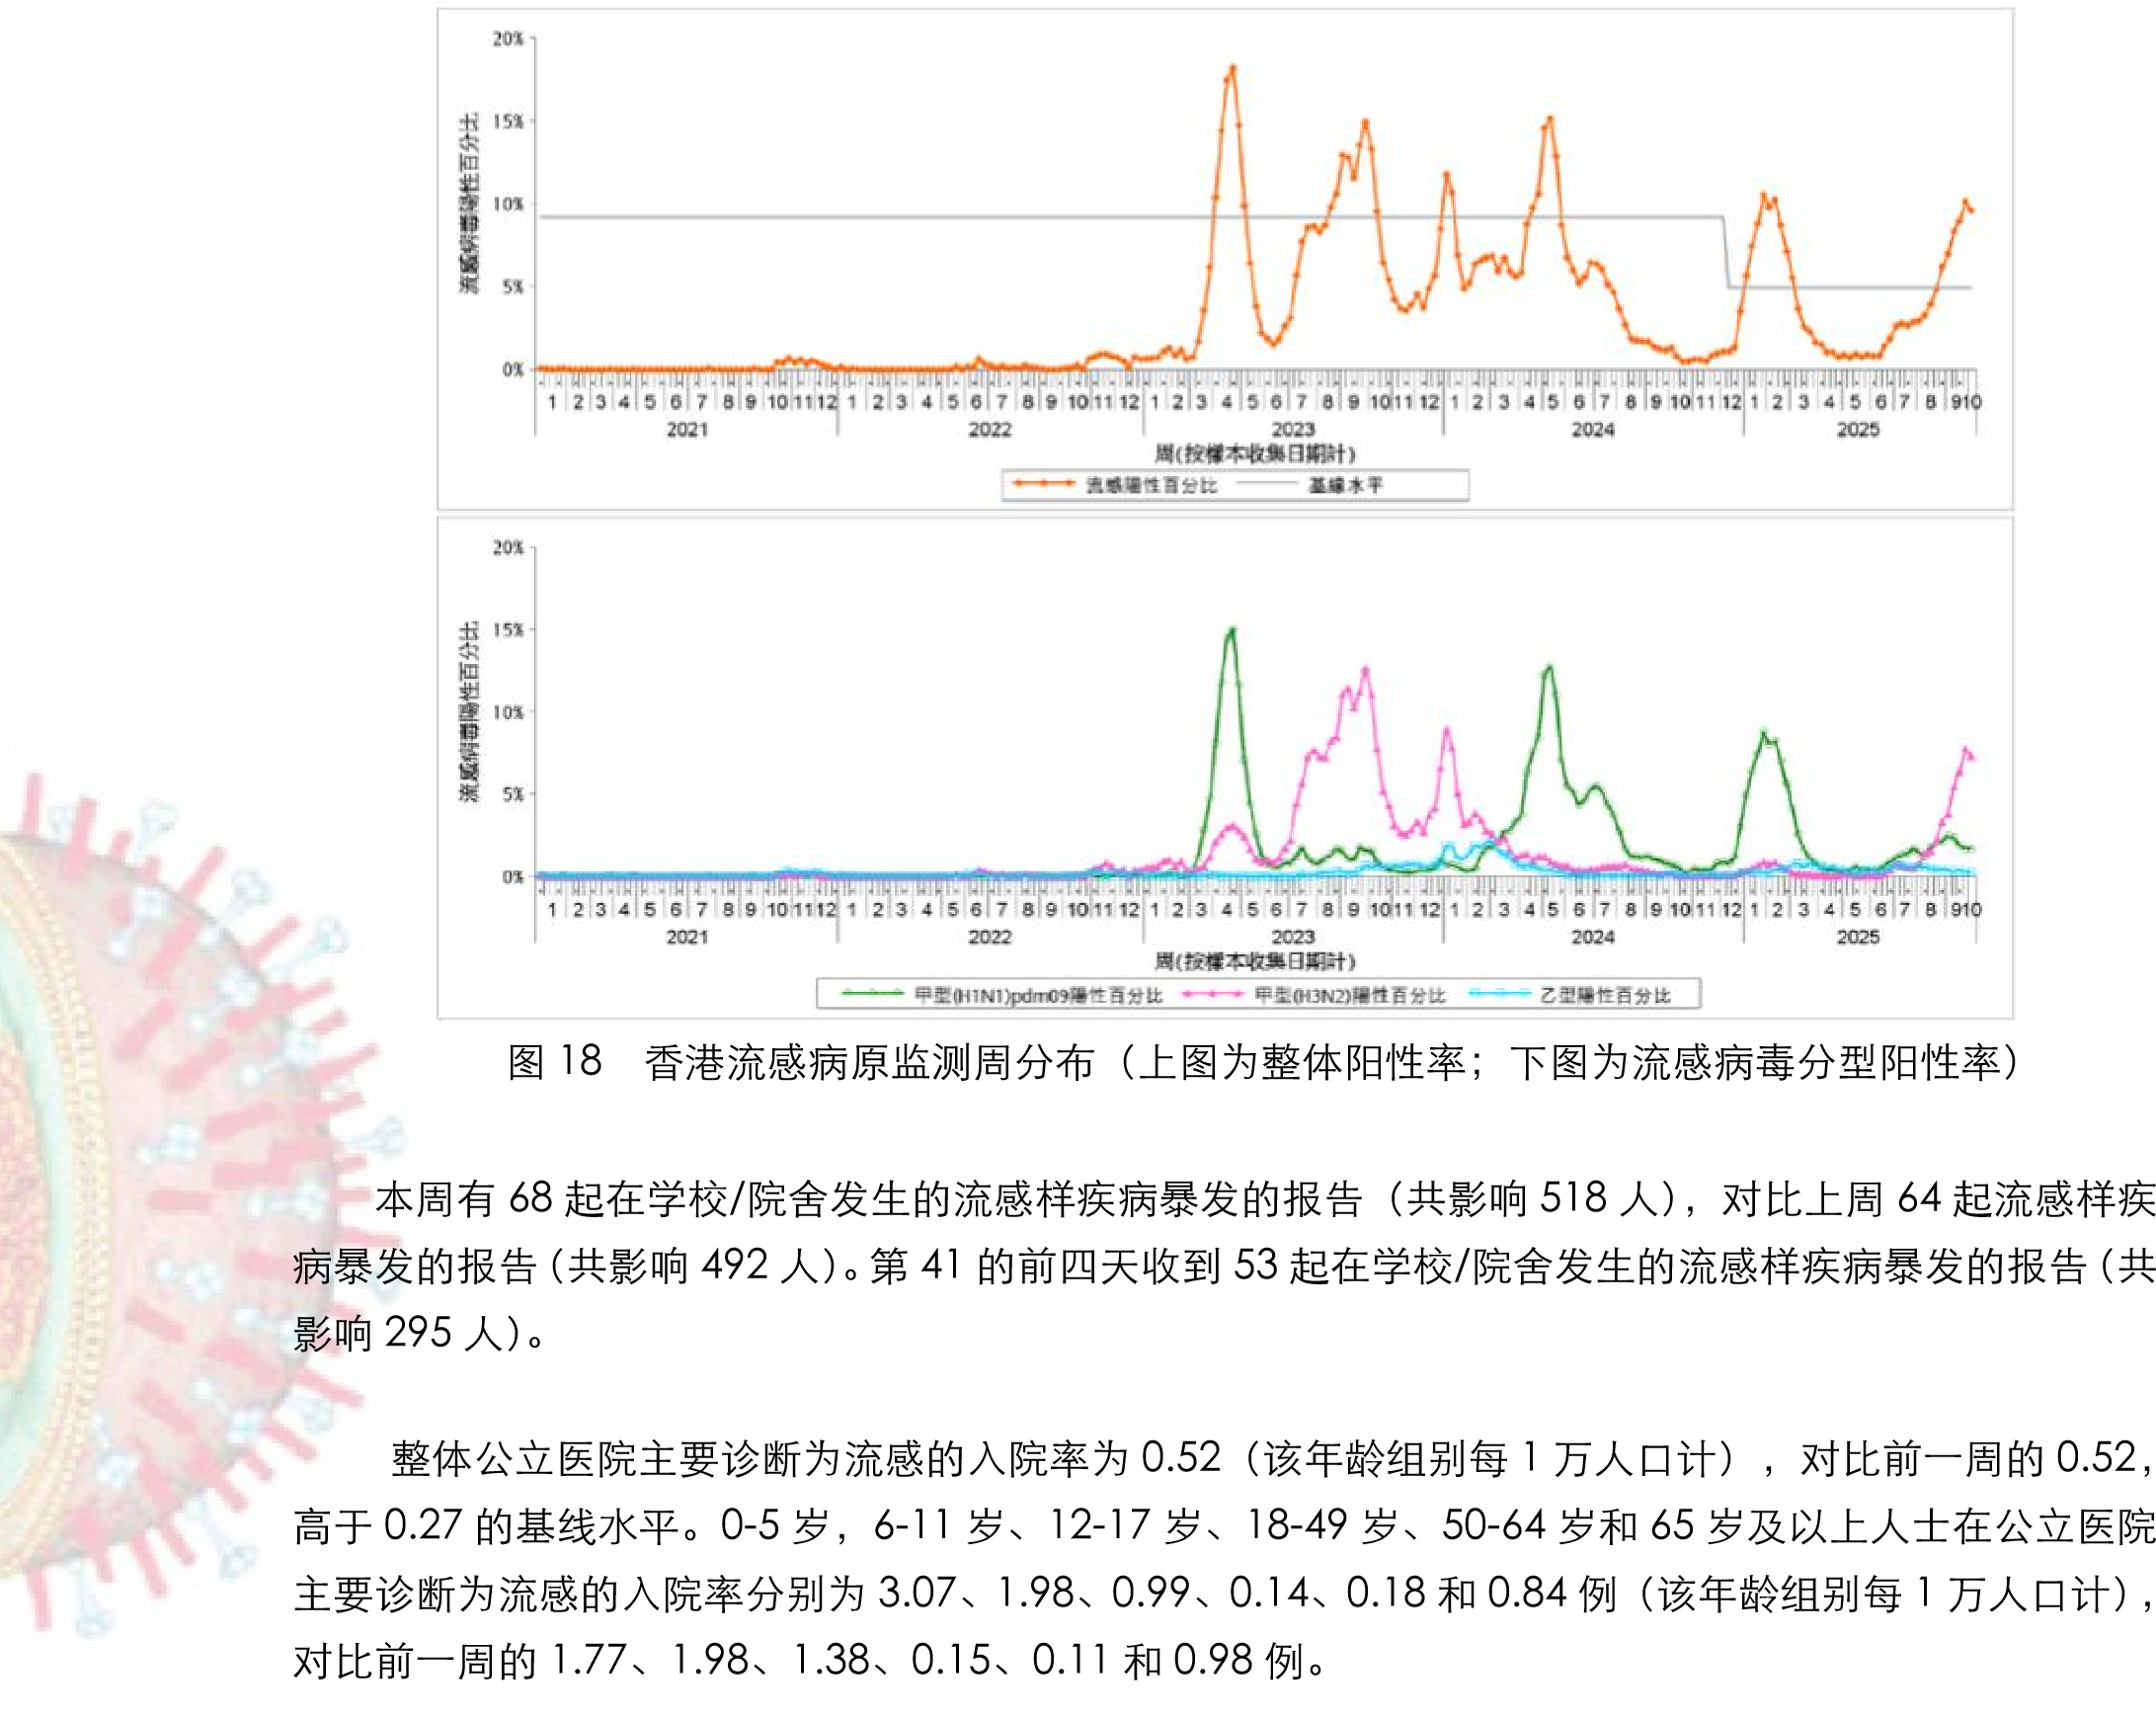8,799 respiratory samples were collected this week, with 846 (9.61%) positive influenza samples detected, including 147 (18%) A(H1N1)pdm09, 644 (79%)A(H3N2) and 26 (3%) influenza B samples. The influenza virus positivity rate was 9.61%, up from the baseline level of 4.94% and down from 10.16% the previous week.

（摘自：[https://www.chp.gov.hk/tc/resources/29/100148.html）](https://www.chp.gov.hk/tc/resources/29/100148.html)

